IT’S THAT TIME AGAIN
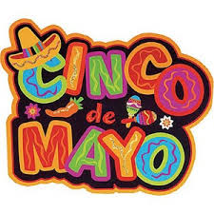
QUEENS COUNTY INSURANCE PROFESSIONALS

ANNUAL CINCO DE MAYO MEETING

VENUE: YERMAN’S IRICH PUB & RESTAURANT
7026 88TH STREET
GLENDALE, NY 11385
718-894-4442

TIME: 6:00 PM

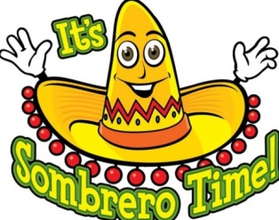

RESERVATION FORM

NAME:_____________________________________________________
AGENCY/COMPANY__________________________________________
PH#_________________________ EMAIL________________________

E-MAIL RESERVATION TO laurieb@mbs-llc.com

